Traffic Violation Detection System

# Manas

Department of Information Technology,

Krishna Engineering College, Ghaziabad, U.P., India.

E-mail: [manas190701@gmail.com](mailto:manas190701@gmail.com)

# Chihit Gaur

Department of Information Technology,

Krishna Engineering College, Ghaziabad, U.P., India.

E-mail: [chihitgaur@gmail.com](mailto:chihitgaur@gmail.com)

# Abhishek Tyagi

Department of Information Technology,

Krishna Engineering College, Ghaziabad, U.P., India.

*Corresponding author*: [abhishektyagi1333@gmail.com](mailto:abhishektyagi1333@gmail.com)

**Dr. Rakesh Kumar Arora**

Associate Professor – Krishna Engineering College,

Krishna Engineering College, Ghaziabad, U.P., India.

E-mail: [rakesharora@krishnacollege.ac.in](mailto:rakesharora@krishnacollege.ac.in)

**Abstract**

One of the biggest worries in the world today is traffic accidents. Daily accident rates are progressively rising. Accidents are a worry not just for one nation, but for the entire world. Today, every profession requires complete focus on the task at hand. And when it comes to driving, the most important factor is the driver's alertness. Data show that drunk driving causes 21% of all fatal accidents. About 168 million adult drivers, or 60% of all drivers, admitted to driving while fatigued in the previous year [5]. This system will help in achieving the goal by using some technologies like OpenCV2, YOLOv3. Around the world, traffic accidents are a leading cause of disability and fatalities. Intelligent vehicle management does not primarily rely on human resources to eliminate human error and improve congestion relief. An intelligent control system based on RFID technology is being introduced in this article. Vehicles are connected to computer systems, intelligent light poles, and other accessible hardware along the path with the use of RFID technology. This proposal uses an intelligent control system that can rack all cars, handle crises, direct traffic, and record traffic infractions along the roadway.

**Keywords-** Traffic violation detection, Computer vision, Image processing, Object detection.

# Introduction

A rise in car ownership can contribute to traffic congestion in metropolitan areas, suggesting that traffic violations are growing more serious both in Bangladesh and internationally. The extensive property destruction and ensuing accidents endanger people’s lives. Technologies for traffic violation detection are needed to address the troubling situation and prevent such terrible outcomes. In order to prevent this, the system consistently enforcing relevant traffic regulations and detaining individuals who disregard them. It is necessary to have a real-time traffic violation detection system since the authorities continually monitor the roads. Since the traffic monitoring system spots transgressions more rapidly, traffic enforcers will have no issue enforcing safe roadways accurately and effectively.

# Related Work

Ou.G et al- implements a real-time traffic infraction detection in a monitoring stream employing concurrent video streams from many cameras and parallel computing algorithms is reported in [1]. Using an enhanced background-updating algorithm and video-based traffic detection, Wang.X implemented real-time traffic infraction detection in [2] and then tracked moving cars using feature-based tracking. Though this project is seeded using a self-developed methodology, it is inspired by the project above. Vehicle detection is typically referred to as an object detection issue. The YOLOv3 model, which makes use of Darknet-53, is used to identify moving vehicle objects from the road. Vehicle detection is followed by a review of the infraction circumstances.

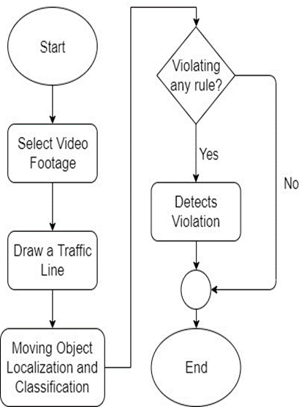

Figure-1 System Operation Depiction

System consists of two main components-

• Vehicle detection model

• A graphical user interface (GUI)

The system receives the roadside video footage first. The film reveals the presence of vehicles. The technology monitors the movement of the cars and assesses whether or not there has been a violation. Figure 1 depicts the system's operation.

The system is interactive for users thanks to the Graphical User Interface (GUI). The user may watch the traffic footage and receive a warning when a violation is identified using the vehicle's bounding box. The GUI allows the user to take more action.

# Methodology

* *Vehicle Classification*

It is possible to identify moving items in the provided video clip. These moving objects are categorized into the appropriate classifications using the object detection model YOLOv3. The YOLO (You Only Look Once) family's third object detection method is called YOLOv3. It is more adept at identifying things and has various methods to increase accuracy. The Darknet-53 architecture is used to construct the classifier model.

**Features:**

1. Bounding Box Predictions: Since YOLOv3 is a single network, it is necessary to calculate the loss for objectivity and classification independently from one another using the same network. YOLOv3 uses logistic regression to predict the objectiveness score, where 1 denotes a bounding box prior that completely overlaps the ground truth object. For each ground truth item, it will only forecast 1 bonding box prior, and any inaccuracy here will result in both classification and detection loss. Other bounding box priors with objectiveness scores higher than the cutoff but lower than the optimal one would also exist. Only the detection loss will experience these problems; the classification loss won't.
2. Class Prediction: Jiménez, F et al predicts Instead of a typical SoftMax Layer, YOLOv3 employs separate logistic classifiers for each class [14]. The purpose of this is to create a multi-label categorization. With the use of multilabel categorization, each box forecasts the classes that the bounding box could include.
3. Predictions across scales: YOLOv3 forecasts boxes at three distinct scales to facilitate detection at changing scales. Then, using a strategy like feature pyramid networks, features are taken from each scale. Using the aforementioned approach, YOLOv3 becomes more adept at making predictions at various sizes. The dimension clusters used to construct the bounding box priors are separated into three scales, each with three bounding box priors, for a total of nine bounding box priors.
4. Feature Extractor: A new Network Darknet-53 is used by YOLOv3. Darknet-53 is deeper than YOLOv2 and features 53 convolutional layers in addition to residuals or shortcut connections. It is more effective than ResNet-101 or ResNet-152 and more potent than Darknet-19.

* *Violation Detection*

Redmon, Josep et al proposes The YOLOv3 model is used to detect moving objects. The incidents of violations are examined when the cars are found. In the user's preview of the provided video footage, a traffic line is painted across the road. The line clearly states that the light is red. Any car that crosses the traffic line while it is red is breaking the law. The bounding box for the discovered items is green. Any infraction occurs when a vehicle crosses the center line when the light is red. The bounding box surrounding the car becomes red when a violation is discovered. [3].

* *Implementation*

Handan U et al implements digital vision This project uses the free source computer vision and machine learning software package OpenCV for image processing [10]. Implementing the car classifier with Darknet-53 makes use of Tensorflow. McCall, J.C et al- Interactive Graphics (GUI) All the settings required by the software are available on the graphical user interface. The program is used for administration and other types of debugging [9]. We don't need to alter any management-related code.

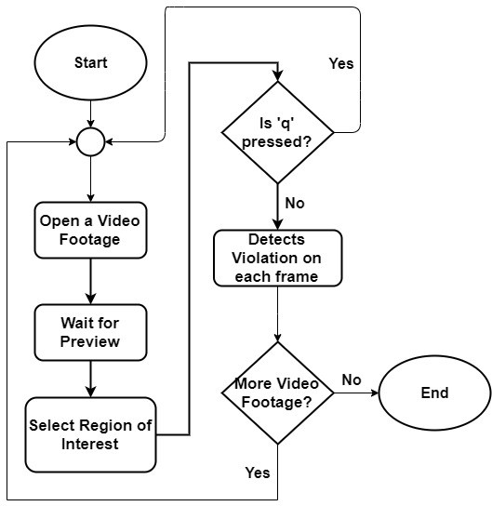

Figure-2 Video processing semaphore

Horry W, J. et al, examines, With the Open item, we may access any video content that has to be opened (Figure-4). The system will obtain a preview of the video after opening it from storage [5]. A frame from the video clip provided is included in the preview. Roads are identified and a traffic line is drawn across them using the preview. Bergama,L.M et al- The administrator's designed traffic line will serve as a traffic signal line. The "Region of interest" item under the "Analyze" option must be selected in order to activate the line drawing capability (Figure-5) [11]. The administrator will next need to choose two places from which to construct a line defining the traffic signal.

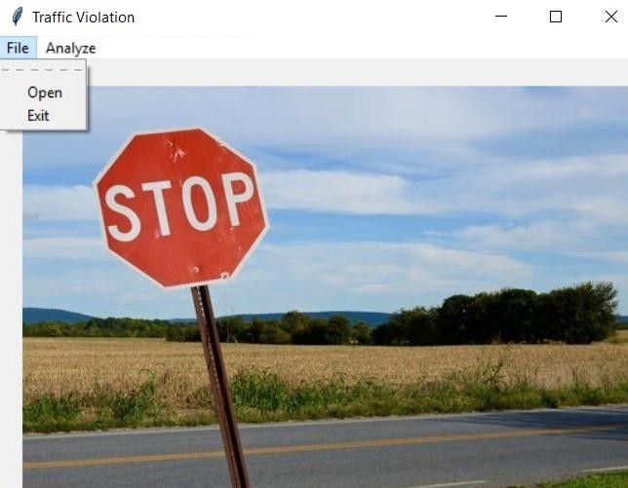

Figure-3 Loading Interface of Software

Escalera, A et al- Selecting the region of interest will start violation detection system [12]. The coordinates of the line drawn will be shown on console (Figure-5). Eriksson, M et al- The violation detection system will start immediately after the line is drawn. At first the weights will be loaded. Then the system will detect objects and check for violations [8]. The output will be shown frame by frame from the GUI.

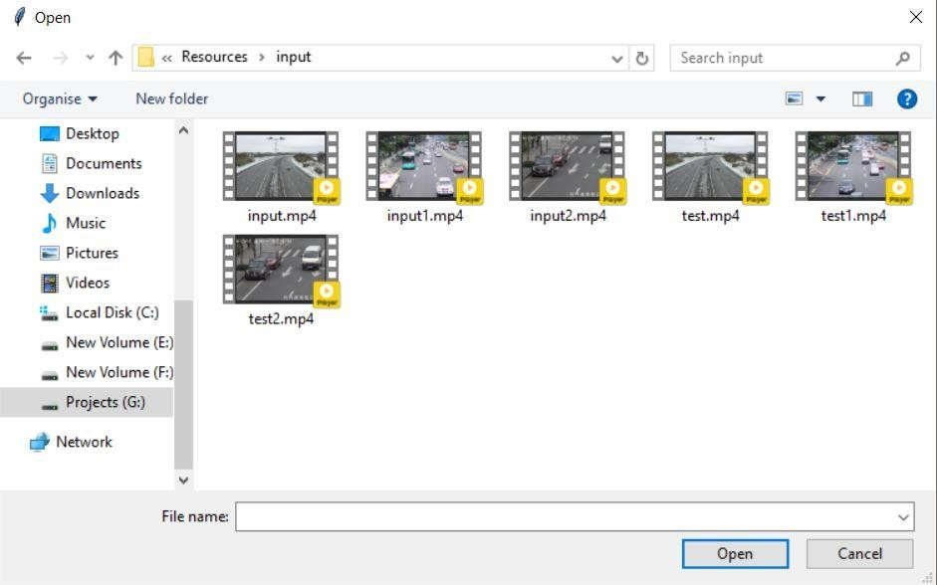

Figure-4 Input interface of software

“Monitoring System” et al - Up to the very last frame of the video, the system will display output. An "output.mp4" file will be created in the background. The file will be located in the Resources' "output" folder. By pressing "q," the procedure will be ended right away [4].

Dong, Y et al- The administrator can upload more video footage from the original file manager after processing one video footage (Figure-2). When all work is finished, the administrator can exit by selecting "Exit" from the File menu [6].

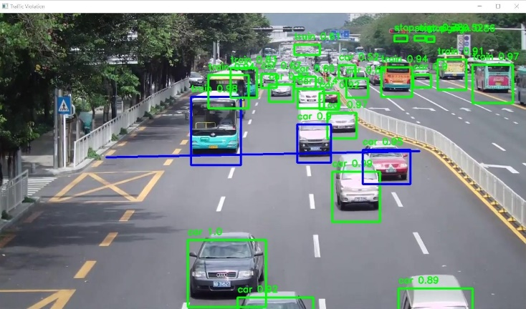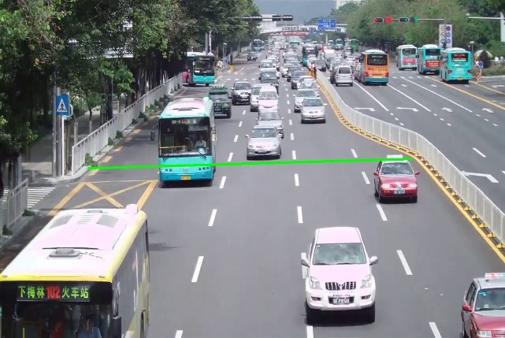

Figure-5 Region of interest selection Figure-6 Bounding box formation



Figure-7 Footage detection algorithm

# Conclusion

The developed algorithm successfully identified the project-specified type of infringement, which is disobeying traffic signals. Horry, W.J et al- The indicated traffic infraction has a varied threshold condition, which makes the convergence of detection different. The system offers traffic signal infraction detection. The system can also process one piece of data at a time [7]. Additionally, the software running is a little sluggish. This may be fixed by utilizing a computer with a GPU or high-speed processor.

C.G-Keller et al- further investigation on the algorithm's suitability for use with other cutting-edge

image processing methods [15]. As a result, by skipping over other superfluous steps carried out by a background difference technique, this may enhance the program runtime of the system. Instead, a computer vision algorithm might be implemented to give the system greater intelligence. Our long-term goal is to strengthen this system by integrating number plate detection with OCR assistance.

**Conflict of Interest**

The authors declare that there is no conflict for this publication.

**Acknowledgments**

This research did not receive any specific grant from funding agencies in the public, commercial, or not-for-profit sectors. The authors would like to thank the editor and anonymous reviewers for their comments that help improve the quality of this work.

# References

1. G. Ou, Y. Gao and Y. Liu, "Real Time Vehicular Traffic Violation Detection in Traffic Monitoring System," in 2012 IEEE/WIC/ACM, Beijing, China, 2012.
2. X. Wang, L.-M. Meng, B. Zhang, J. Lu and K.-L. Du, "A Video-based Traffic Violation Detection System," in MEC, Shenyang, China, 2013.
3. Joseph Redmon and Ali Farhadi, "YOLOv3: An Incremental Improvement".
4. Monitoring System,” in 2012 IEEE/WIC/ACM, Beijing, China 2012.
5. W, J, Horry.; Leach, M.F- Driver-Initiated Distractions: Examining Strategic Adaptation for In-Vehicles task Initiation. Acid. Anal. Prev. 2009,41,115-122.
6. Y, Dong.; Hu, Z.; Chimera, K.; Murayama, N. Driver In attention Monitoring System for Intelligent Vehicles: A Review. IEEE Intel. Transp. Syst. 2011, 12, 596–614.
7. W.J, Horry.; Leach, M.F Garbed, A. Assessing the Awareness of Performance Decrements in Distracted Drivers. Acid. Anal. Prev. 2008, 41, 675–682.
8. M, Eriksson.; Panicle polos, P.N. Driver Fatigue: A Vision-Based Approach to Automatic Diagnosis. Transp. Res. Part C Emerge. Technol. 2001, 9, 399–413. Sensors 2014, 14 22126.
9. J.C, McCall.; Trivedi, M.M. Video-Based Lane Estimation and Tracking for Driver Assistance: Survey, System, and Evaluation. IEEE INTAL. Transp. Syst. 2006, 7, 20–37.
10. U, Handan.; Kalie, T.; C.; Werner and, M.; Snellen, W.V. An Image Processing System for Driver Assistance. Image Vis. Comput. 2000,18, 367–376.
11. L.M, Bergama.; Nuevo, J.; Sotelo, M.A.; Berea, R.; Lopez, M.E. Real-Time system for monitoring driver vigilance. IEEE Intell. Transp. Syst. 2006, 7, 63–77.
12. A, Escalera.; Armingol, J.M.; Mata, M. Traffic sign recognition and analysis for intelligent vehicles. Image Vis. Comput. 2003, 12, 247–258.
13. A, Broggi.; Cerri, P.; Ghidoni, S.; Grisleri, P.; Jung, H.G. A New Approach to Urban Pedestrian Detection for Automatic Braking. IEEE Intell. Transp. Syst. 2009, 10, 594–605.
14. F, Jiménez.; Naranjo, J.E.; Gómez, O. Autonomous maneuvering systems for collision avoidance on single carriageway roads. Sensors 2012, 12, 16498–16521.
15. C.G, Keller.; Dang, T.; Fritz, H.; Jools, A.; Rabe, C.; Gavrila, D.M. Active pedestrian safety by automatic braking and evasive steering. IEEE Intell. Transp. Syst. 2011, 12, 1292–1304
16. Dr. Rakesh Kumar Arora.; Chandani Jain.; Yash Gupta.; Automated System For Monitoring Smart Farms. International Journal of Modern Trends in Engineering and Research Vol.7 Issue 5 May’2020